**AEM Book Website Development – Work Summary**

**1️. Created Book Detail Template**

* Developed a **Book Detail Template** to serve as a base for all book pages.
  + **Title Component** → Displays the book title.
  + **Text Component** → Provides an overview of the book.
  + **Image Component** → Displays the book cover.
  + **Teaser Component** → Highlights key themes.

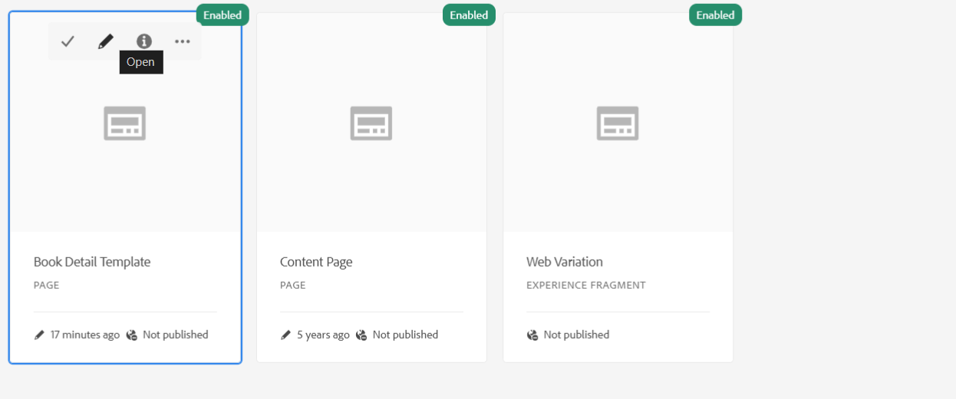

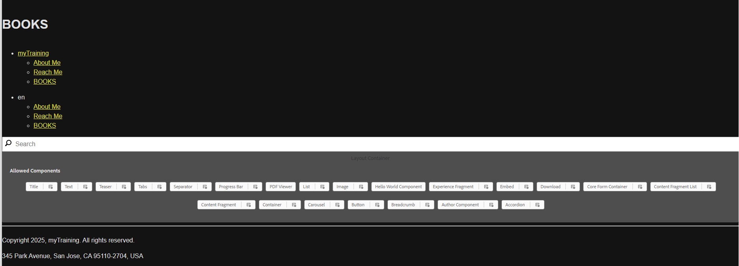

**2️. Created 10 Book Pages**

* Used the **Book Detail Template** to create **10 unique book pages** with different names and URLs.
* Example pages created:

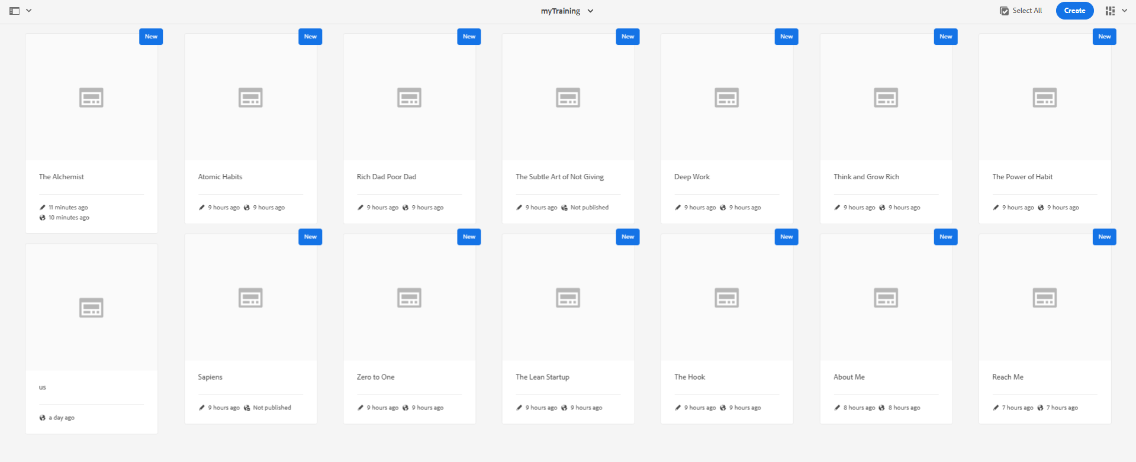

**3️. Created Header (Navigation Component in XF)**

* Developed the **header** inside an **Experience Fragment (XF)**.
* Added navigation links:  
   **Books** (Dropdown linking to the 10 book pages)  
   **About Me**  
   **Reach Me**

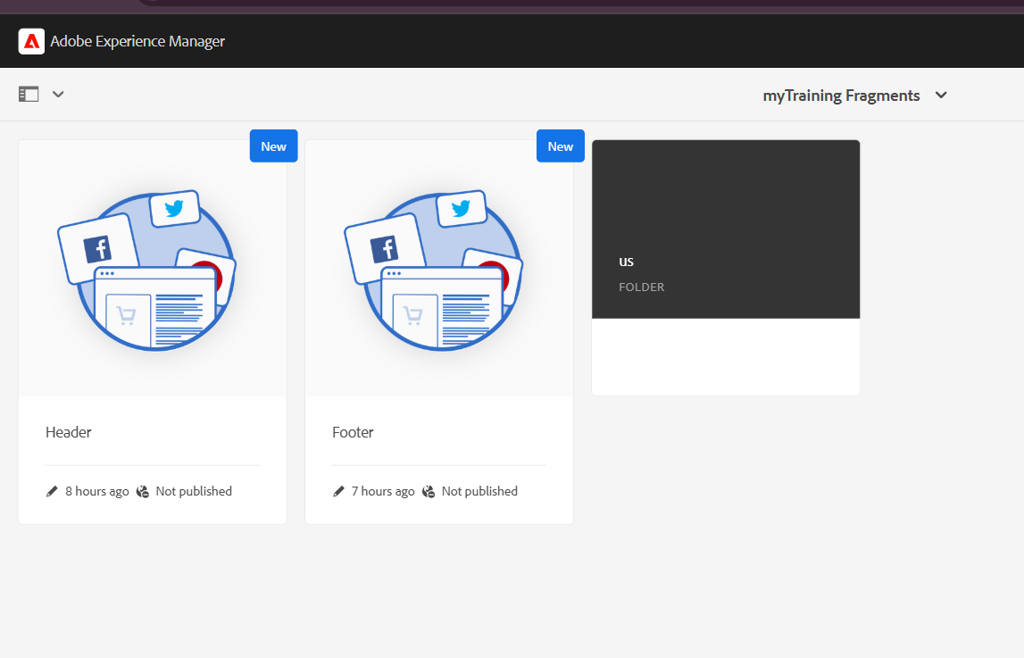

**5️. Created Multi-Field Component**

A custom **multi-field component** was developed to allow adding multiple authors or book reviews dynamically.

* **Fields in the Multi-Field Component:**
  + **Author Name** (Text)
  + **Review Text** (Multi-line Text)
  + **Reviewer Name** (Text)

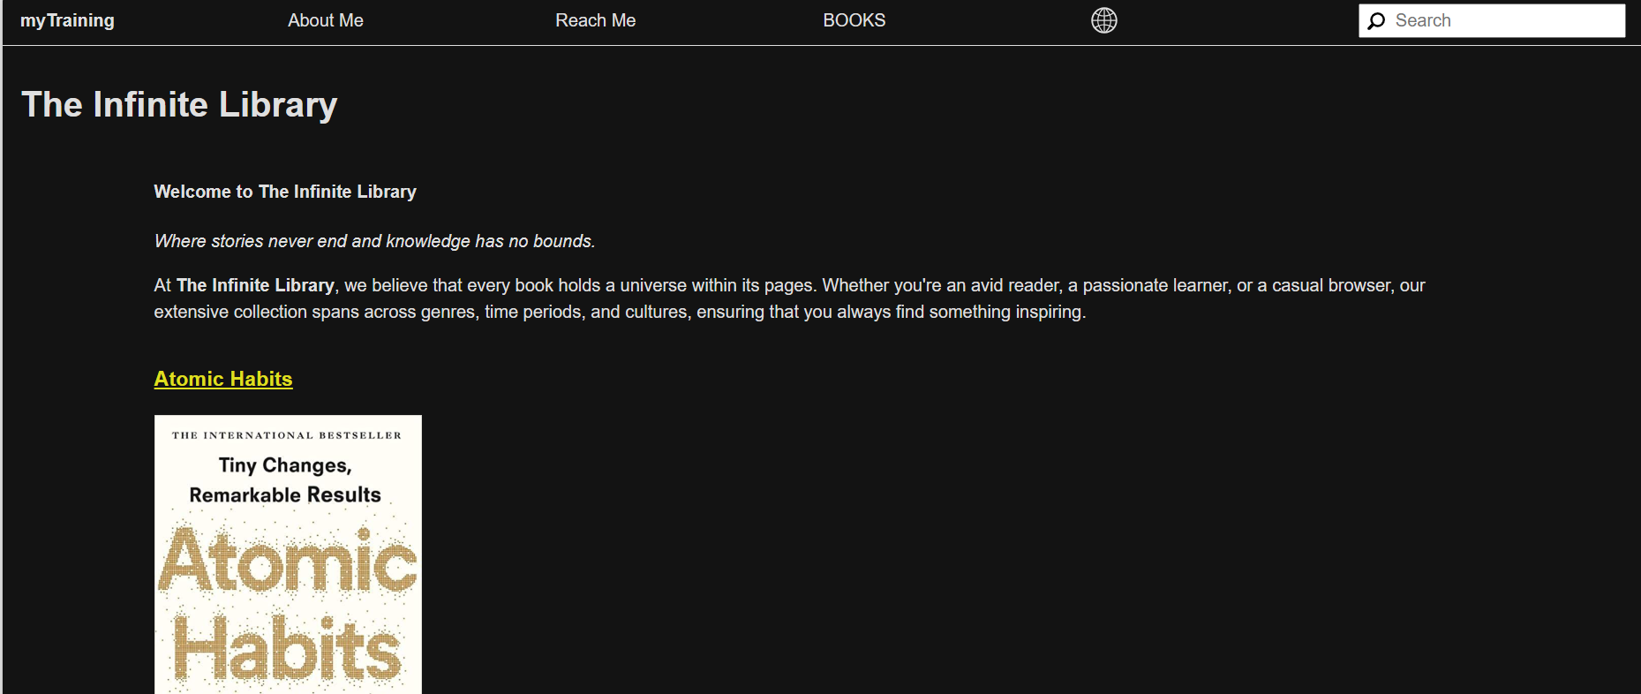

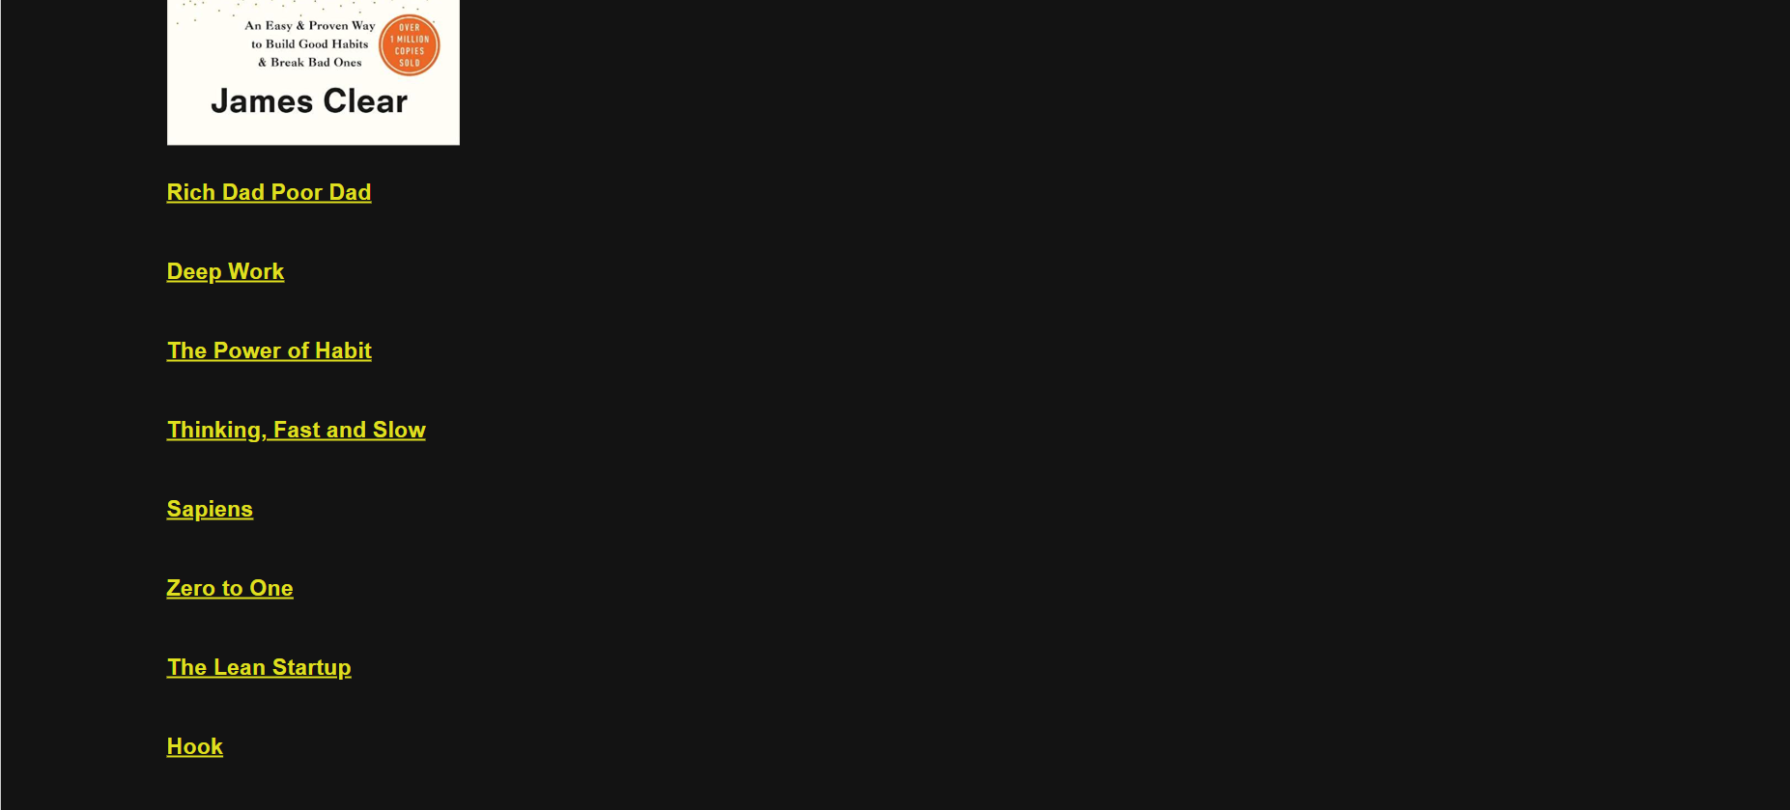

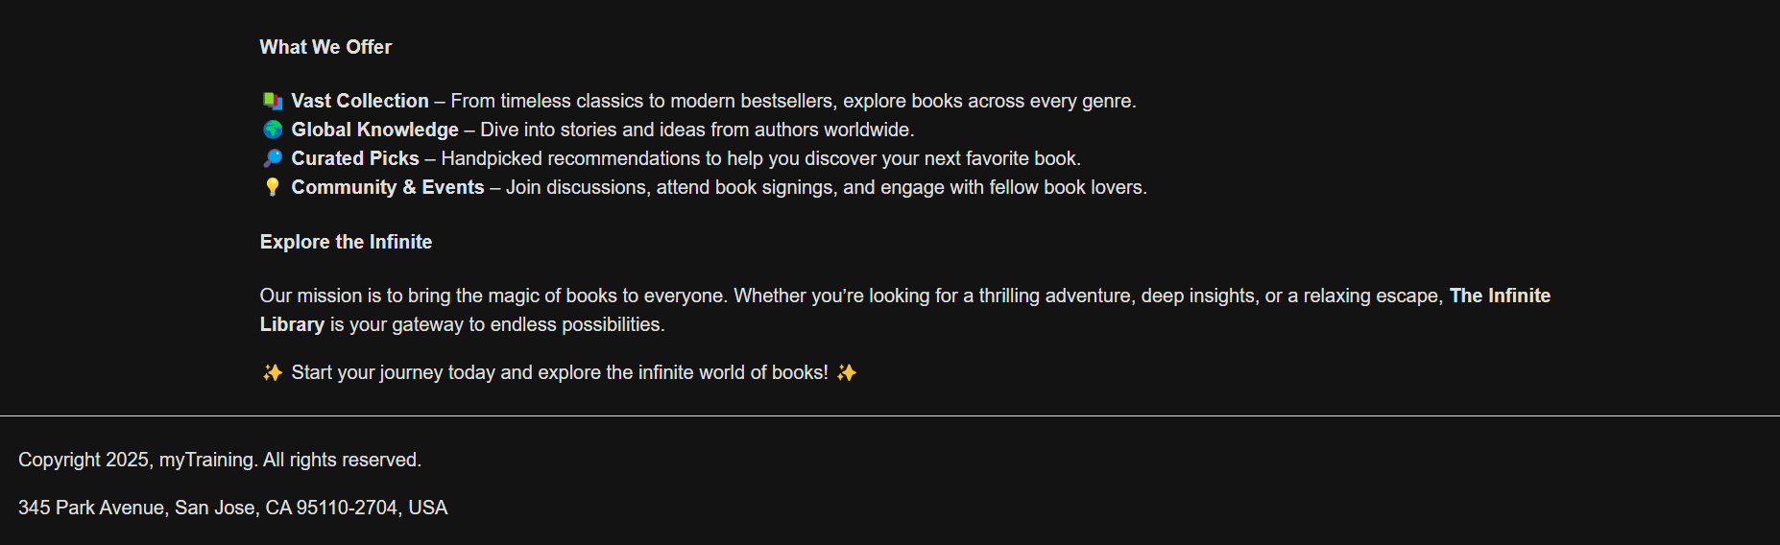

**6. Inside the atomic habits book:**



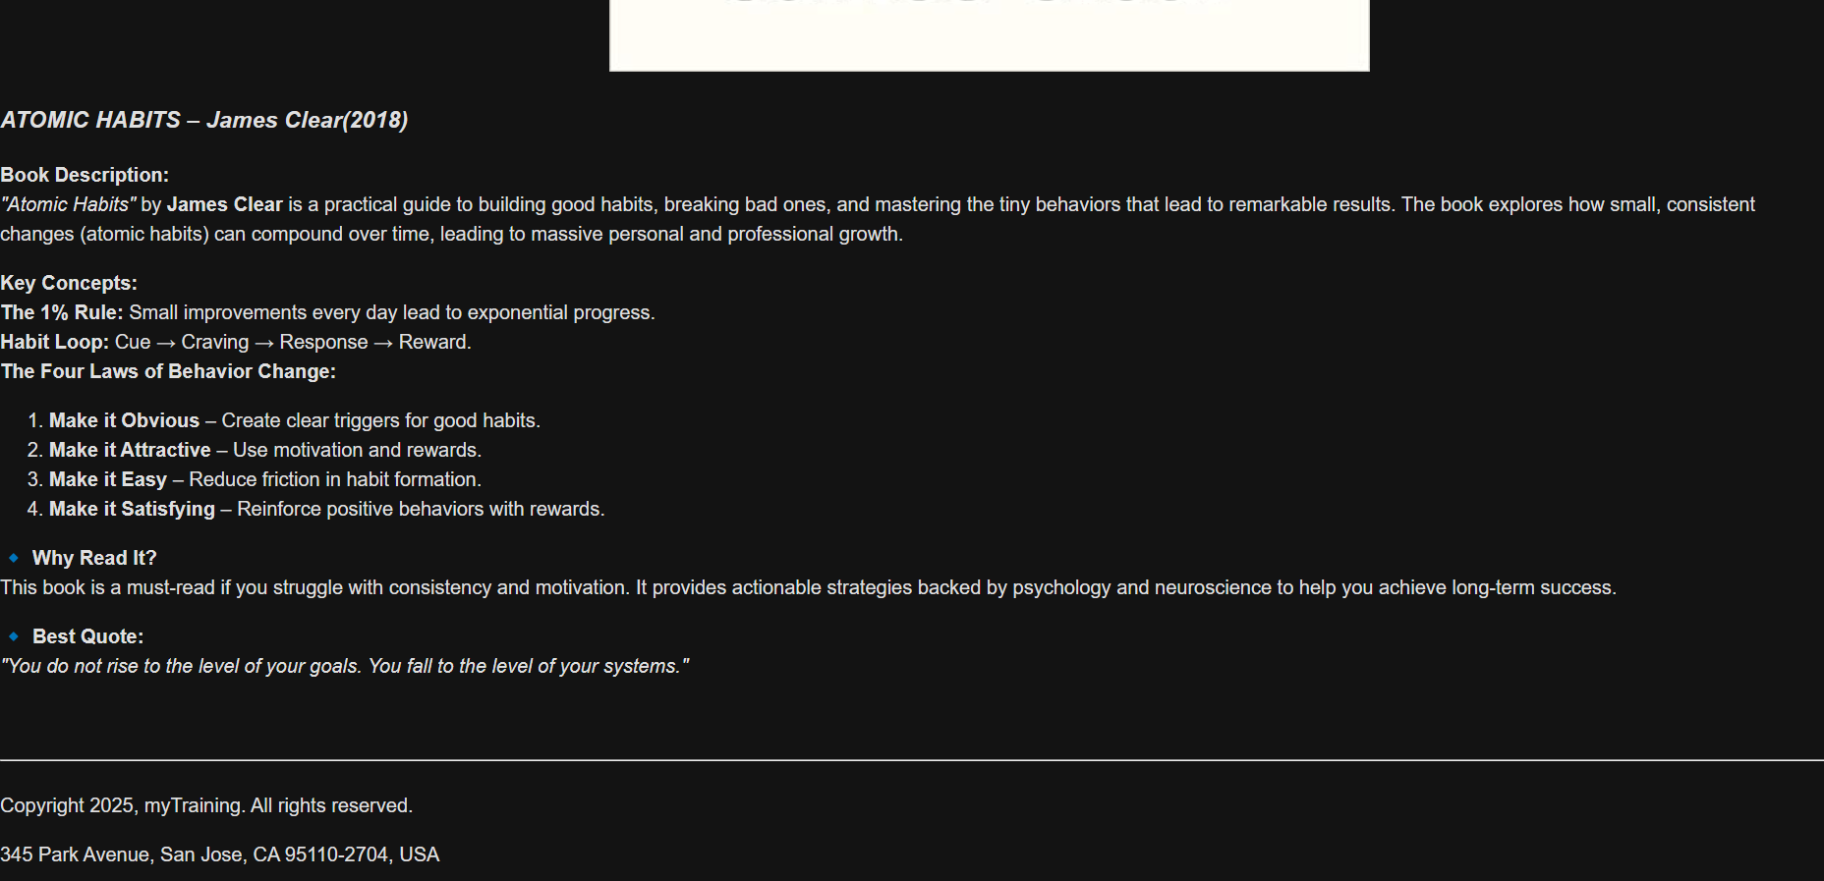

**7. SEARCH BAR TO SEARCH BOOK**



**8. ABOUT ME PAGE:**

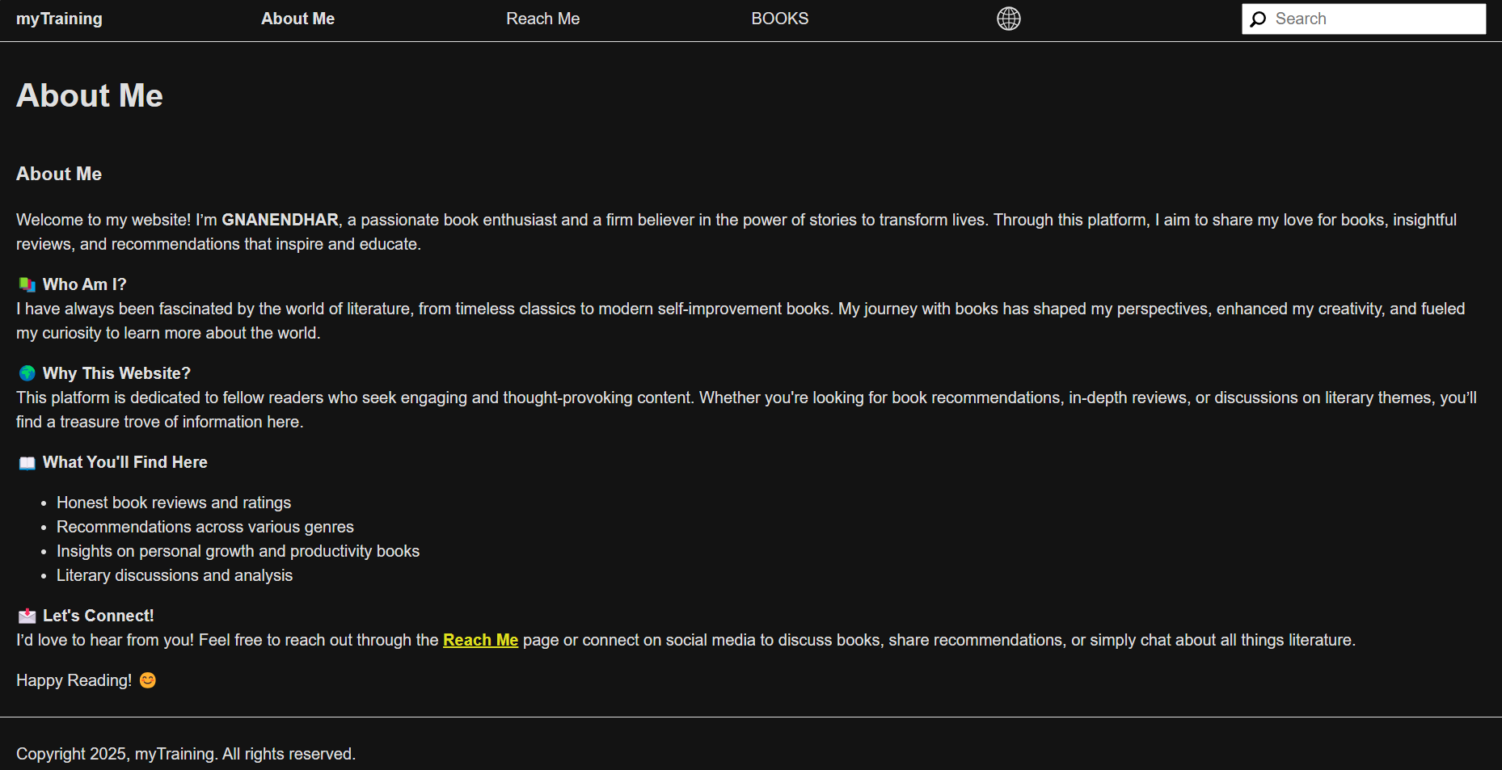

**9. REACH US PAGE:**

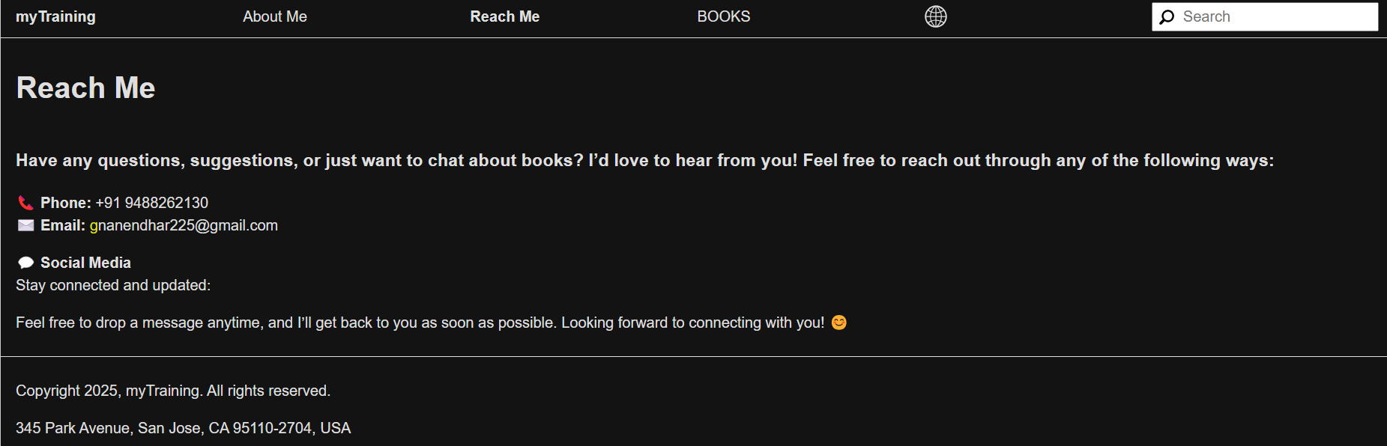

**Conclusion**

This document summarizes the completed tasks for the **AEM Book Website** project. The site now includes a **Book Detail Template**, **10 book pages**, a **responsive header & footer**, and a **multi-field component** for dynamic content.